JAVA /ANDROID STUDIO PROJECT – WEEK 08/09 – PDA SCREENSHOTS OF PLANNING/CHANGES TO PLAN AND DEVELEPMENT SCREENSHOTS

WED 31ST JAN

End of day – updated plan for last Day

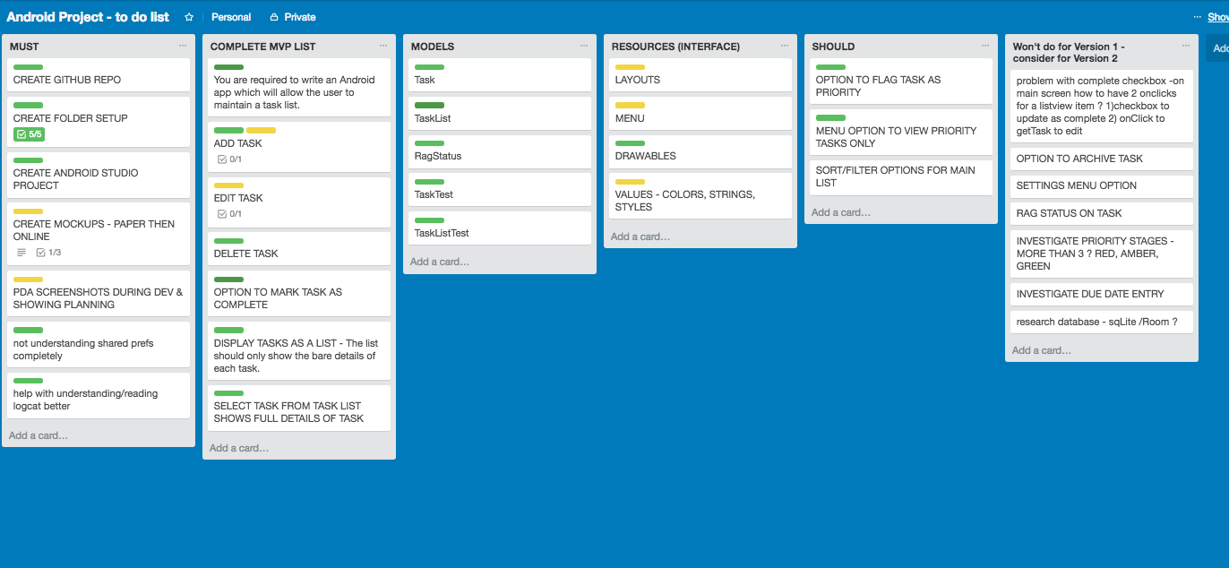

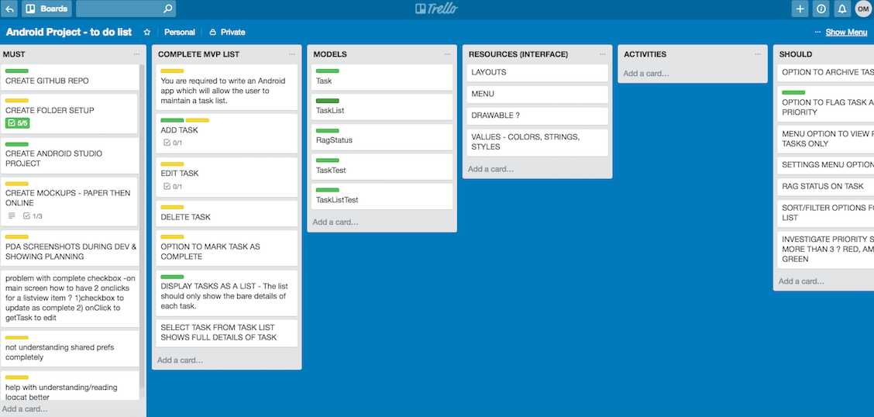

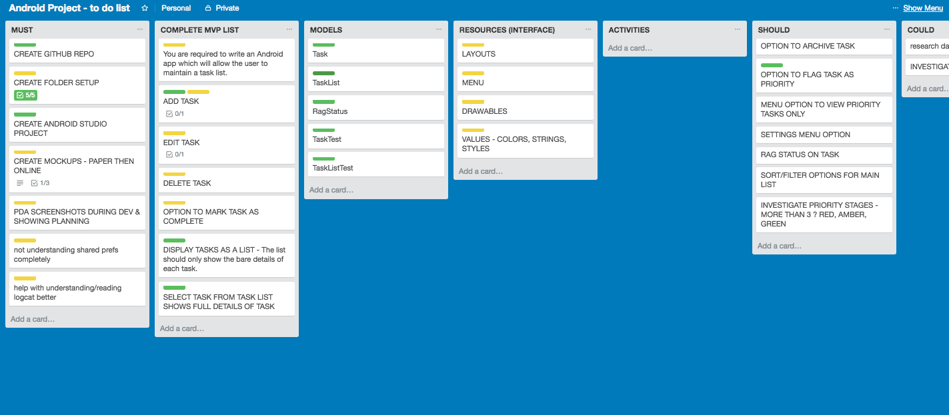

Decided after research not to include “completed task” checkbox on Main List screen – too complicated/difficult to do with Shared prefs – better with a database.

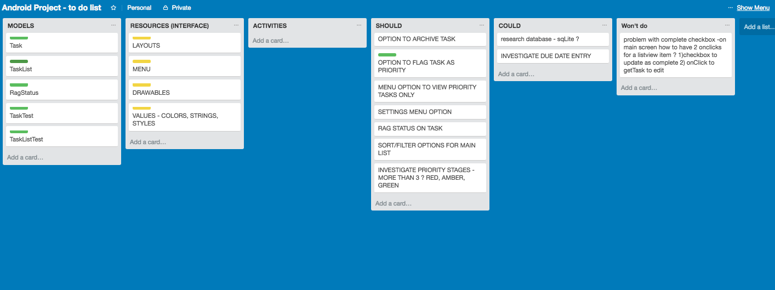

27 Jan

